PDA week 5 evidence

|  |  |  |  |  |
| --- | --- | --- | --- | --- |
| **Week 5** | **Unit** | **Ref.** | **Evidence** | **Done** |
| A & D | A.D 1 | A Use Case Diagram | ✓ |
| A & D | A.D 2 | A Class diagram. | ✓ |
| A & D | A.D 3 | An Object diagram. | ✓ |
| A & D | A.D 4 | An Activity Diagram | ✓ |
| A & D | A.D 6 | Produce an Implementations Constraints plan detailing the following factors:  *Hardware and software platforms  *Performance requirements  *Persistent storage and transactions  *Usability  *Budgets  *Time | ✓ |
| P | P 5 | Create a user sitemap. | ✓ |
| P | P 6 | Produce two wireframe designs. | ✓ |
| P | P 10 | Take a screenshot of an example of pseudocode for a function. | ✓ |
| P | P 13 | Show user input being processed according to design requirements. Take a screenshot of:  * The user inputting something into your program  * The user input being saved or used in some way | ✓ |
| P | P 14 | Show an interaction with data persistence. Take a screenshot of:  * Data being inputted into your program  * Confirmation of the data being saved |  |
| P | P 15 | Show the correct output of results and feedback to user. Take a screenshot of:  * The user requesting information or an action to be performed  * The user request being processed correctly and demonstrated in the program |  |

A.D 1

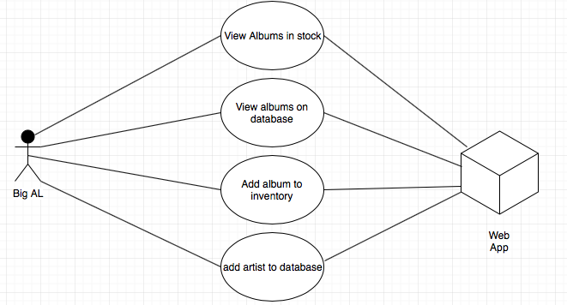

A.D 2

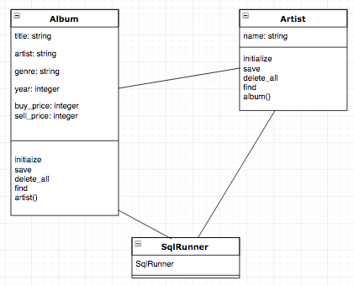

A.D 3

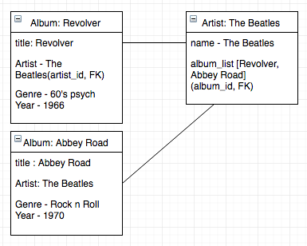

A.D 4

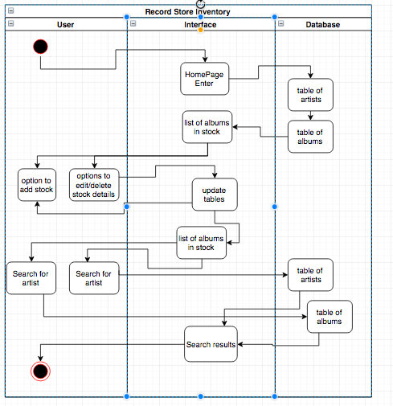

P.5

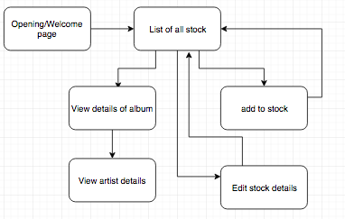

A.D 6

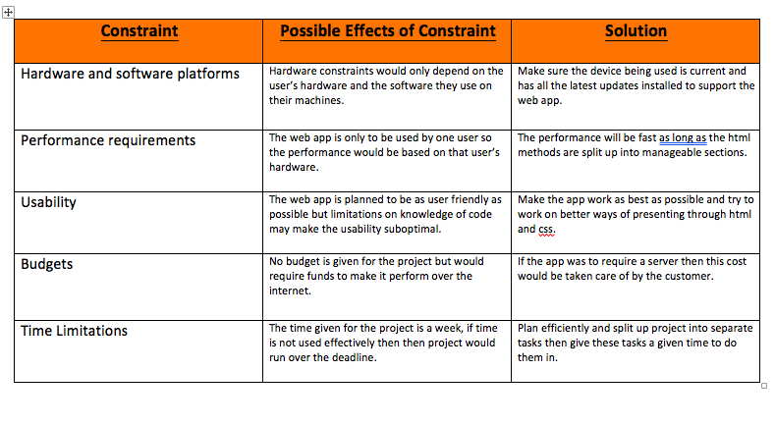

P6

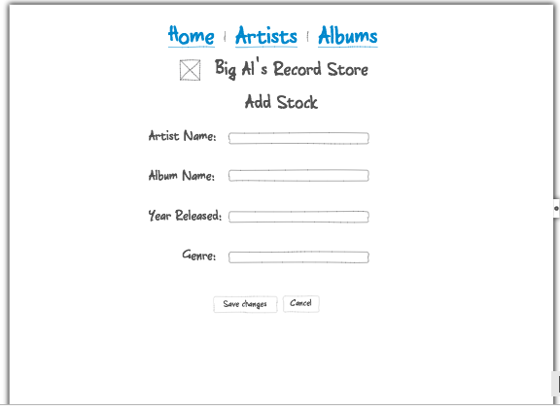

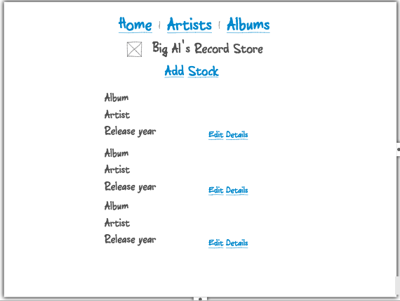

p10

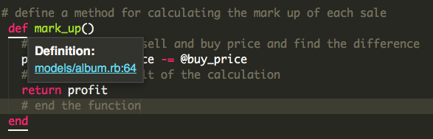

p13, P14





P 15



